# CS 211 Homework #2

Note that this is an individual assignment and all work must be your own. Be sure to show your work when appropriate. This assignment is due **in class** on Tuesday, October 9, 2018.

1. [3] Remove 5 from the following AVL tree; draw the results:

|  |  |
| --- | --- |
| **Original** | **After removal** |
|  |  |
| **After 1st Rotation** | **After 2st Rotation (may or may not be required)** |
|  |  |

1. [3] Insert the value "8" into the following AVL tree. Draw the result:

|  |  |
| --- | --- |
| **Original** | **After removal** |
|  |  |
| **After 1st Rotation** | **After 2st Rotation (may or may not be required)** |
|  |  |

3. [3] Add 45 to the following AVL tree.

|  |  |
| --- | --- |
| **Original** | **After insert** |
|  |  |
| **After 1st Rotation** | **After 2st Rotation (may or may not be required)** |
|  |  |

4. **Binary Heaps** Starting with an empty binary **min heap**, show the following.

1. [3] The final state of the heap, in tree form, after adding in the values: 5, 4, 3, 6, 7, 8, 10, 2, 9, 1
2. [2] The state of the heap, in tree form, after two Dequeue() operations
3. [1] The final, array-based version of the heap

|  |  |  |  |  |  |  |  |  |  |
| --- | --- | --- | --- | --- | --- | --- | --- | --- | --- |
|  |  |  |  |  |  |  |  |  |  |
| 0 | 1 | 2 | 3 | 4 | 5 | 6 | 7 | 8 | 9 |

5. [3] Merge the following two **binomial heaps**

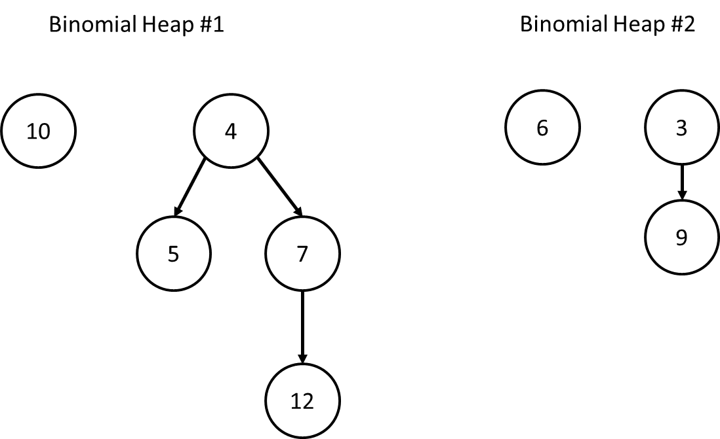

6. [3] Enqueue 10 to the following **skew heap**. Draw the results.

